We have discussed-

* Binary tree is a special tree data structure.
* In a binary tree, each node can have at most 2 children.
* In a binary tree, nodes may be arranged in any random order.

**Binary Search Tree-**

|  |
| --- |
| Binary Search Tree is a special kind of binary tree in which nodes are arranged in a specific order. |

In a binary search tree (BST), each node contains-

* Only smaller values in its left sub tree
* Only larger values in its right sub tree

**Example-**

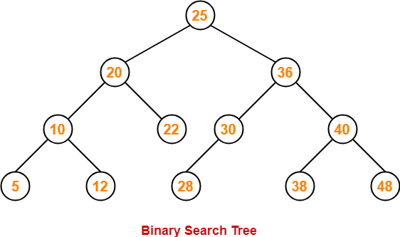

**Number of Binary Search Trees-**

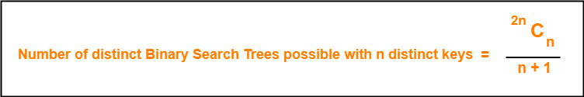

**Example-**

Number of distinct binary search trees possible with 3 distinct keys

= 2×3C3 / 3+1

= 6C3 / 4

= 5

If three distinct keys are A, B and C, then 5 distinct binary search trees are-

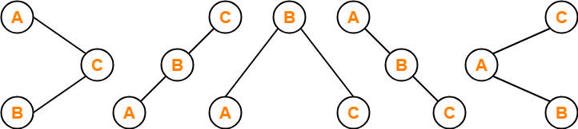

**Binary Search Tree Construction-**

Let us understand the construction of a binary search tree using the following example-

**Example-**

Construct a Binary Search Tree (BST) for the following sequence of numbers-

50, 70, 60, 20, 90, 10, 40, 100

When elements are given in a sequence,

* Always consider the first element as the root node.
* Consider the given elements and insert them in the BST one by one.

The binary search tree will be constructed as explained below-

**Insert 50-**

https://www.gatevidyalay.com/wp-content/uploads/2018/07/Binary-Search-Tree-Construction-Step-01.png

**Insert 70-**

* As 70 > 50, so insert 70 to the right of 50.

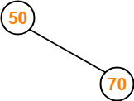

**Insert 60-**

* As 60 > 50, so insert 60 to the right of 50.
* As 60 < 70, so insert 60 to the left of 70.

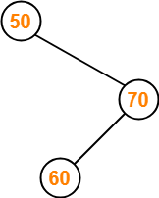

**Insert 20-**

* As 20 < 50, so insert 20 to the left of 50.

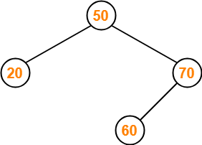

**Insert 90-**

* As 90 > 50, so insert 90 to the right of 50.
* As 90 > 70, so insert 90 to the right of 70.

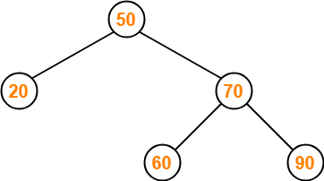

**Insert 10-**

* As 10 < 50, so insert 10 to the left of 50.
* As 10 < 20, so insert 10 to the left of 20.

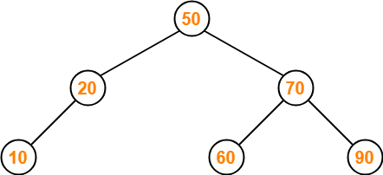

**Insert 40-**

* As 40 < 50, so insert 40 to the left of 50.
* As 40 > 20, so insert 40 to the right of 20.

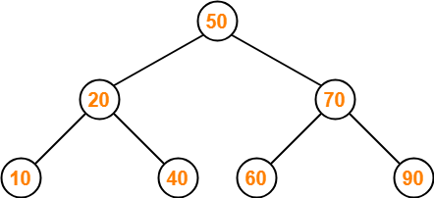

**Insert 100-**

* As 100 > 50, so insert 100 to the right of 50.
* As 100 > 70, so insert 100 to the right of 70.
* As 100 > 90, so insert 100 to the right of 90.

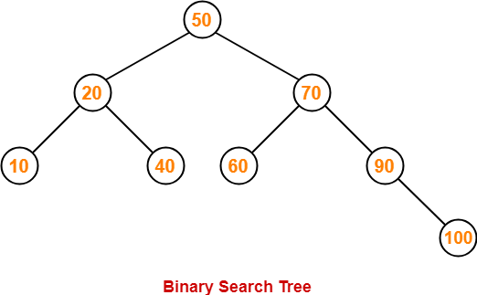

This is the required Binary Search Tree.

To gain better understanding about Binary Search Trees,

[**Watch this Video Lecture**](https://www.youtube.com/watch?v=Qat40osl21g)

**PRACTICE PROBLEMS BASED ON BINARY SEARCH TREES-**

**Problem-01:**

A binary search tree is generated by inserting in order of the following integers-

50, 15, 62, 5, 20, 58, 91, 3, 8, 37, 60, 24

The number of nodes in the left subtree and right subtree of the root respectively is _____.

1. (4, 7)
2. (7, 4)
3. (8, 3)
4. (3, 8)

**Solution-**

Using the above discussed steps, we will construct the binary search tree.

The resultant binary search tree will be-

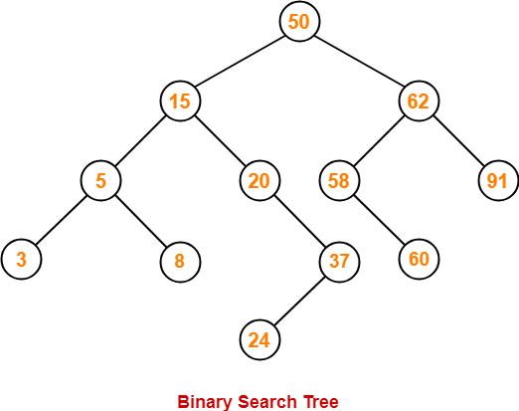

Clearly,

* Number of nodes in the left subtree of the root = 7
* Number of nodes in the right subtree of the root = 4

Thus, Option (B) is correct.

**Problem-02:**

How many distinct binary search trees can be constructed out of 4 distinct keys?

1. 5
2. 14
3. 24
4. 35

**Solution-**

Number of distinct binary search trees possible with 4 distinct keys

= 2nCn / n+1

= 2×4C4 / 4+1

= 8C4 / 5

= 14

Thus, Option (B) is correct.

**Problem-03:**

The numbers 1, 2, …, n are inserted in a binary search tree in some order. In the resulting tree, the right subtree of the root contains p nodes. The first number to be inserted in the tree must be-

1. p
2. p+1
3. n-p
4. n-p+1

**Solution-**

Let n = 4 and p = 3.

Then, given options reduce to-

1. 3
2. 4
3. 1
4. 2

Our binary search tree will be as shown-

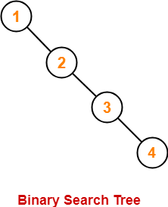

Clearly, first inserted number = 1.

Thus, Option (C) is correct.

**Problem-04:**

We are given a set of n distinct elements and an unlabeled binary tree with n nodes. In how many ways can we populate the tree with given set so that it becomes a binary search tree?

1. 0
2. 1
3. n!
4. C(2n, n) / n+1

**Solution-**

Option (B) is correct.